CPSC 535 8/22/2022 Day 1

1. Syllabus
   1. We must have access to the class website
   2. Lectures = in-person or Zoom
   3. In-class assignments = Zoom mandatory
      1. Work in groups of 3
      2. There will be a Google Doc for it
   4. Exam = Proctorio, in-person only
   5. We started off with the roster. There will always be attendance.
   6. Next week we have our first class assignment
      1. Groups of 3 on Zoom
      2. DO NOT MISS!
   7. We are going to go back to Big-O shit
   8. Exam
      1. Midterm 1 =
      2. Final = 6-13
2. Lecture
   1. Terminology
      1. 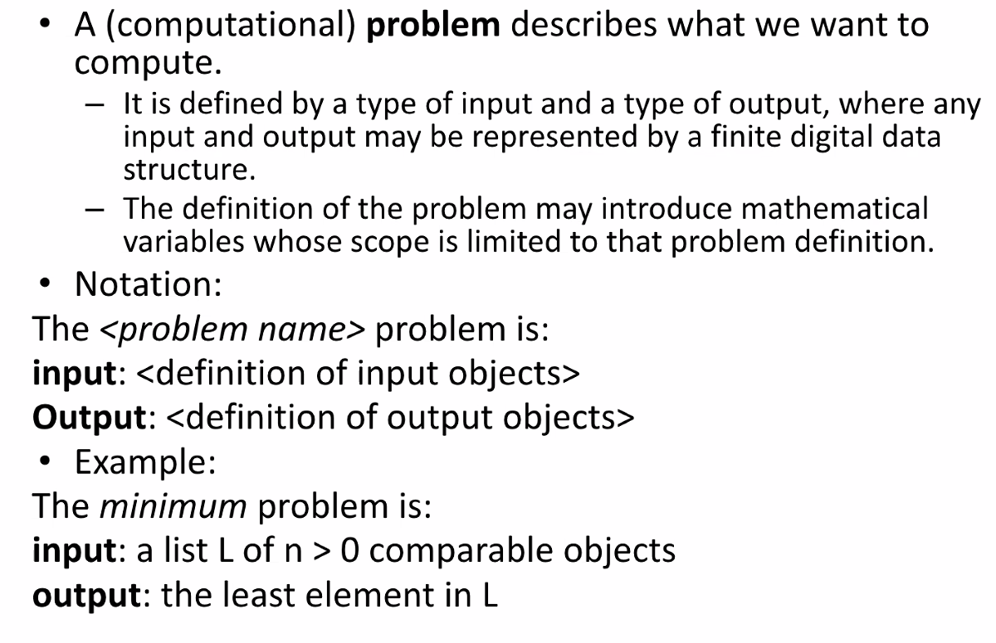
      2. Input and output must be finite
      3. 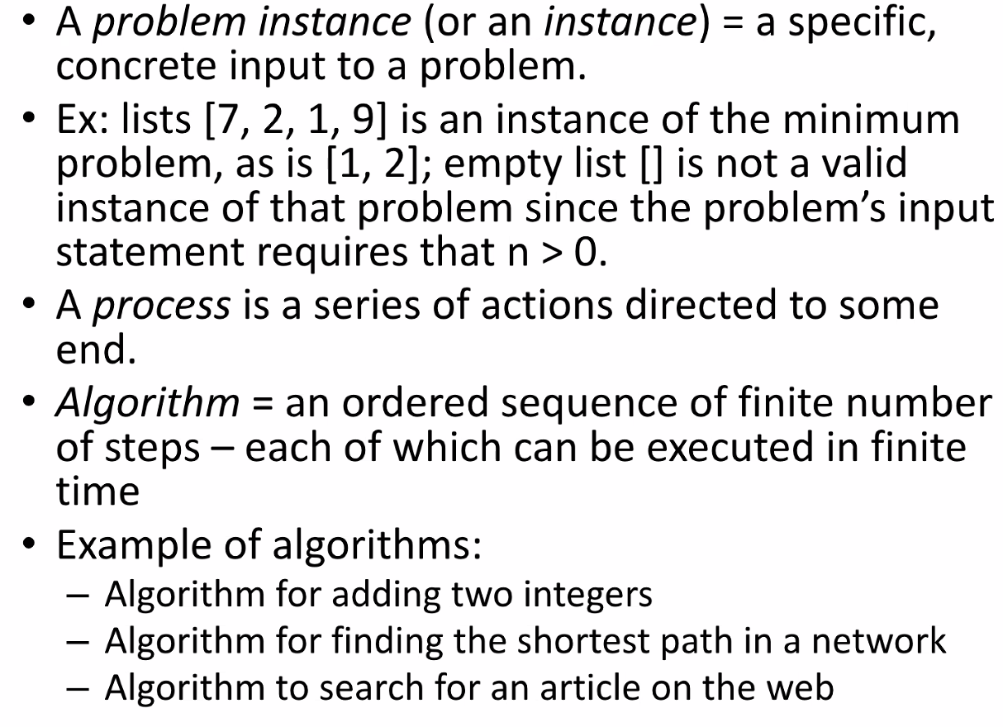
         1. Empty is not valid because statement required n > 0
   2. 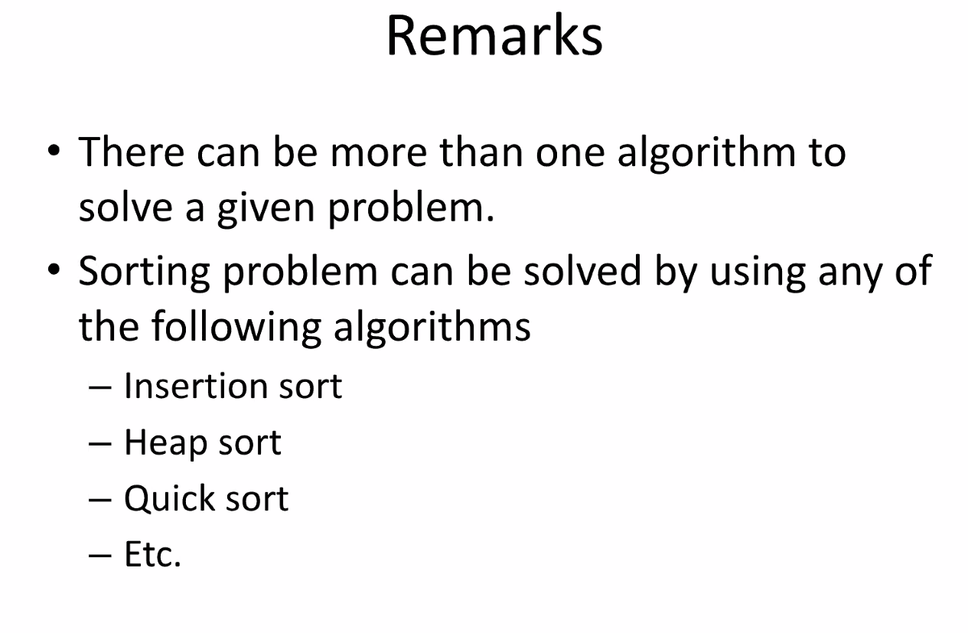
   3. 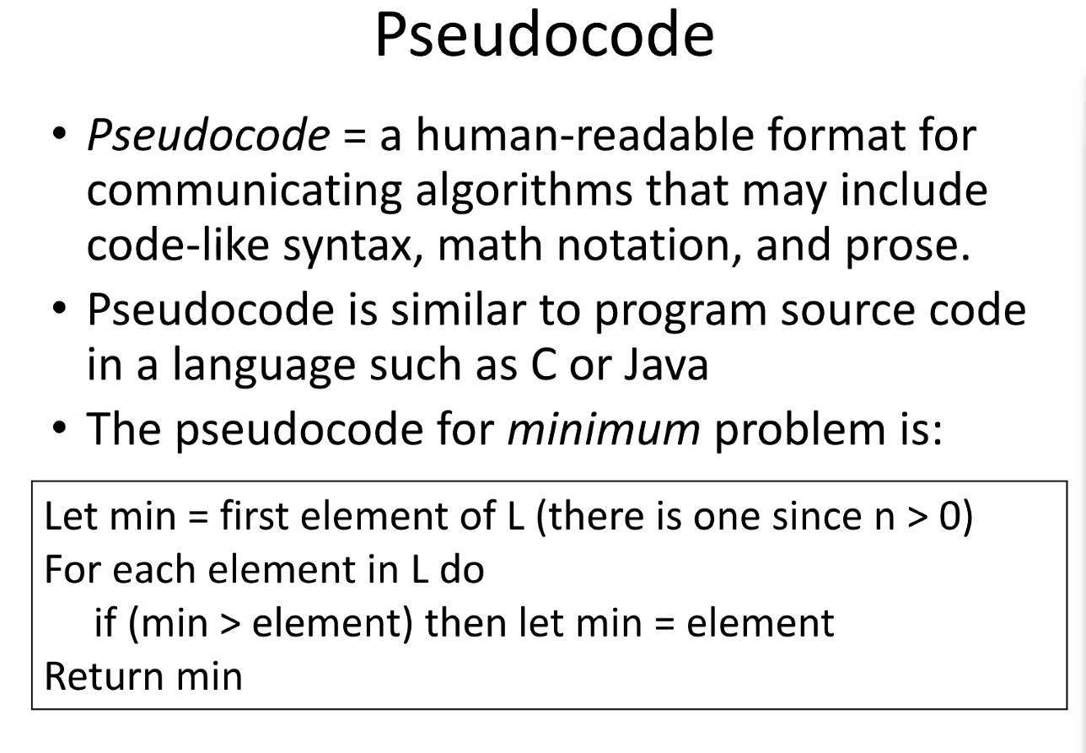
   4. 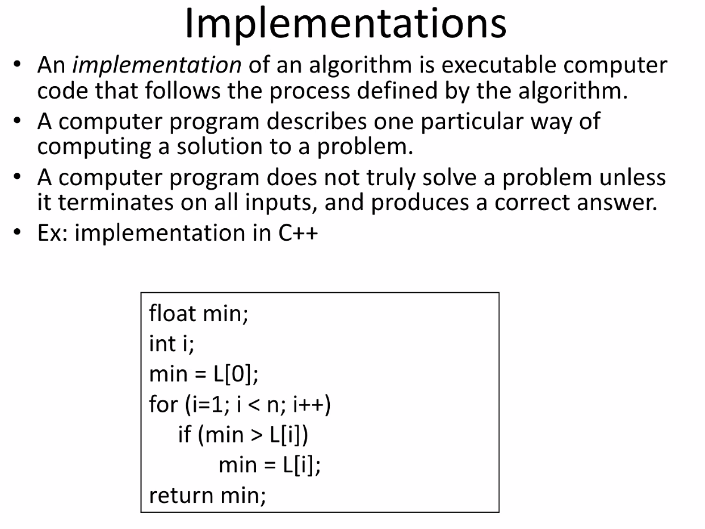
      1. The actual implementation is different from pseudocode though Prof. will accept both as answers
   5. 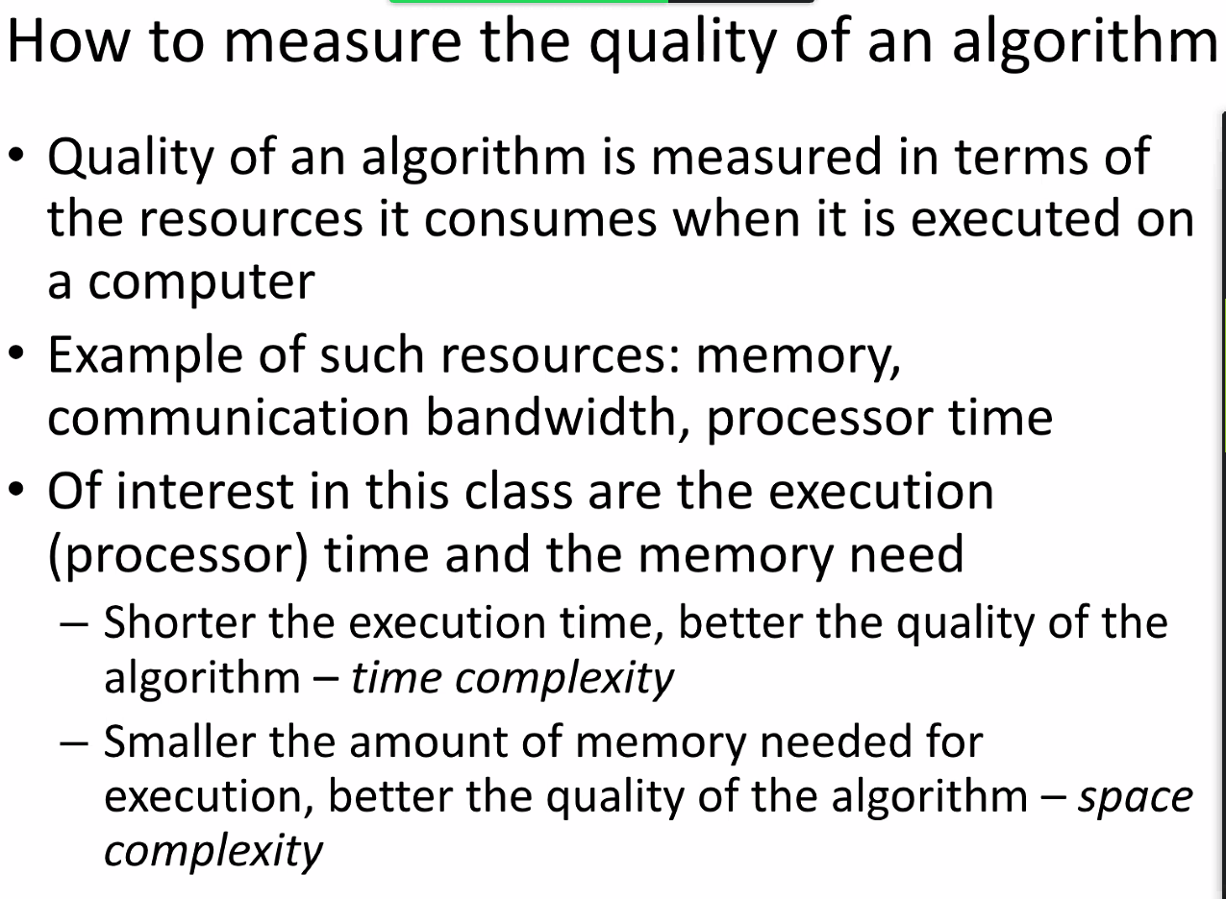
   6. 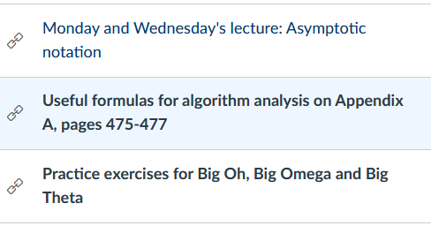
   7. 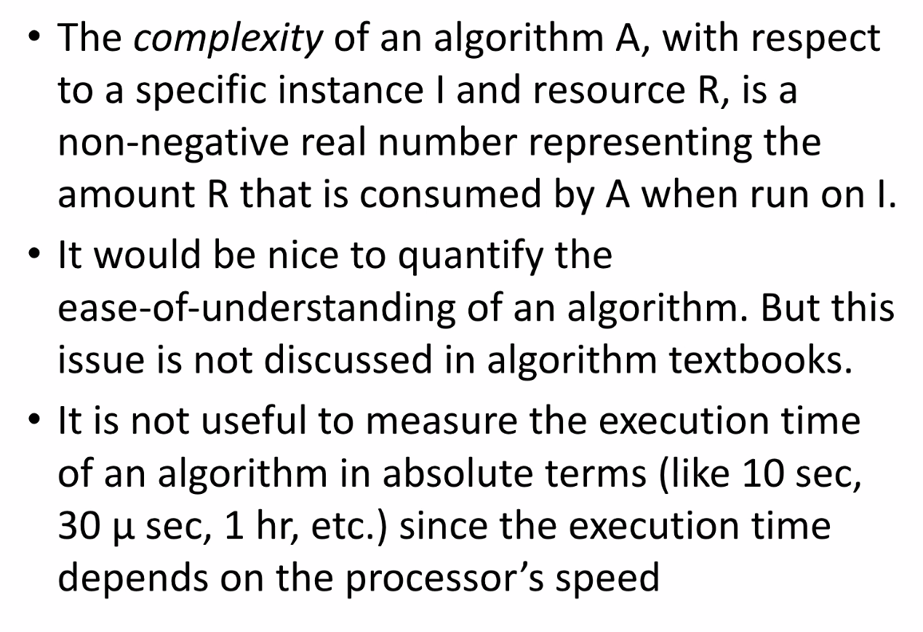
   8. 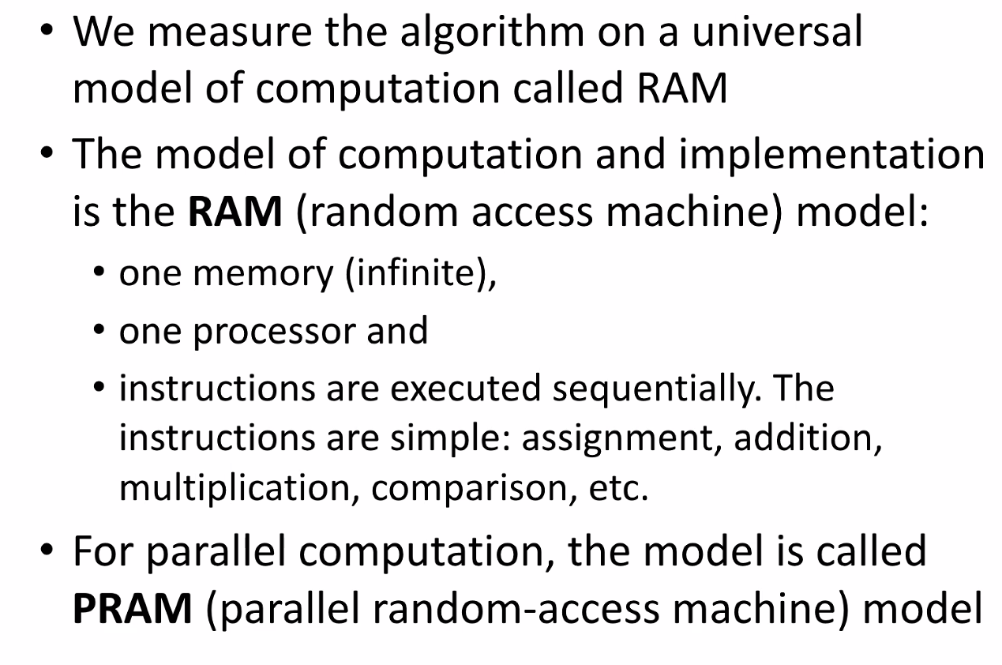
   9. 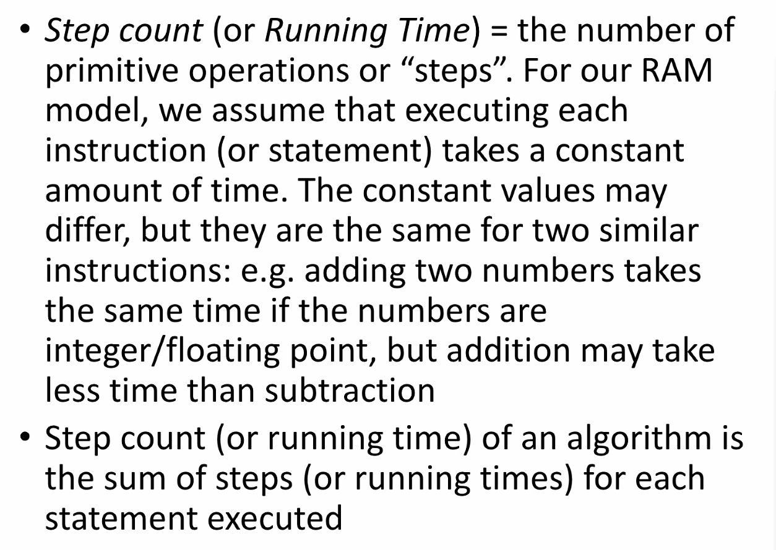
   10. 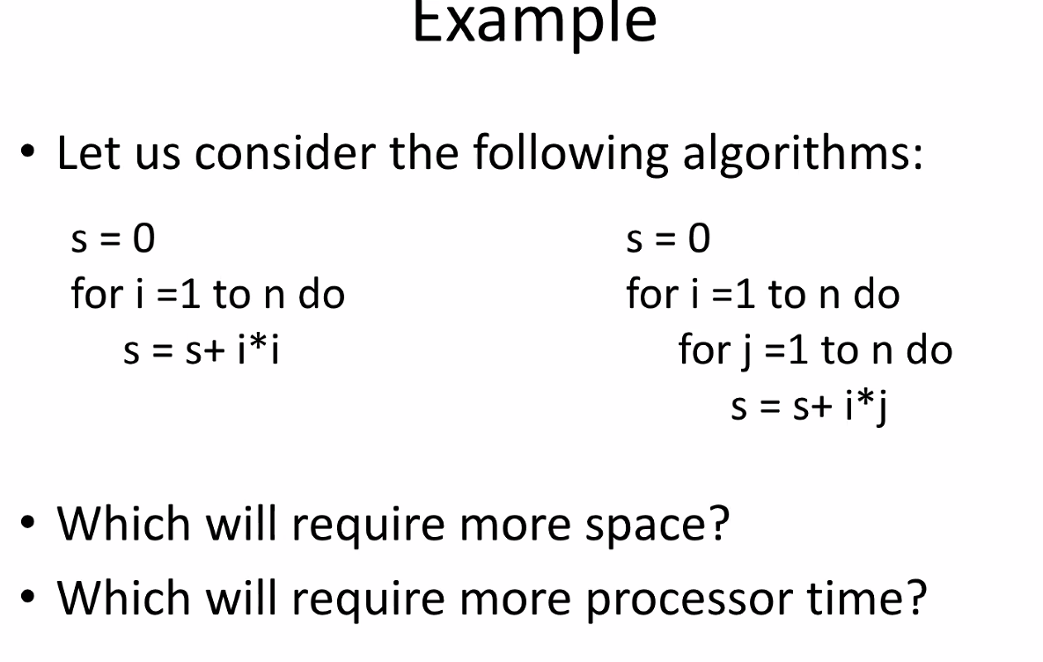
   11. 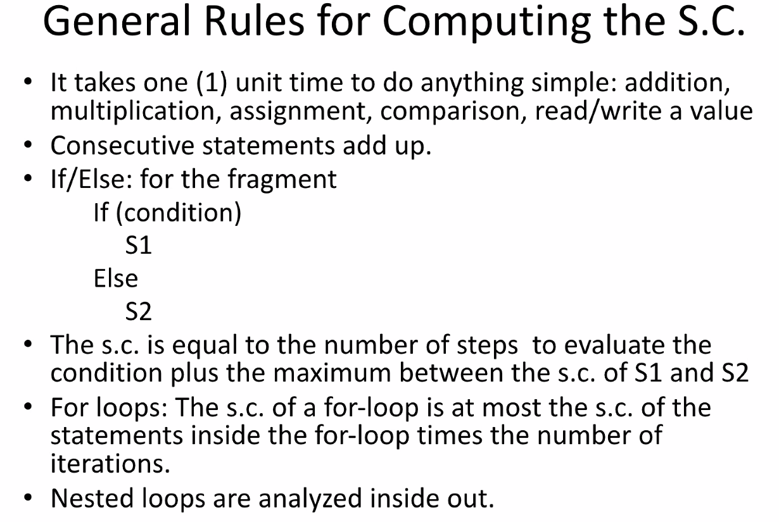
   12. 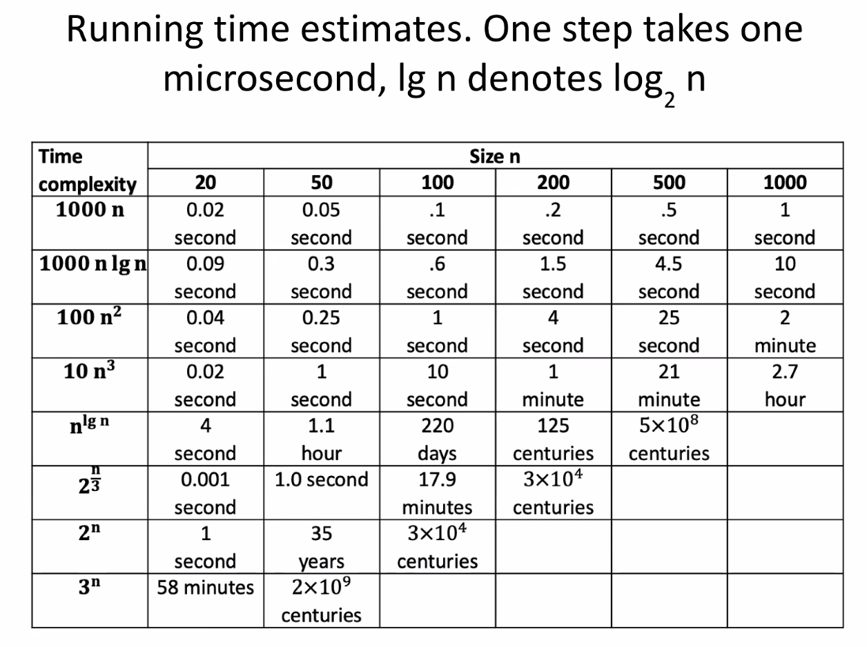
   13. 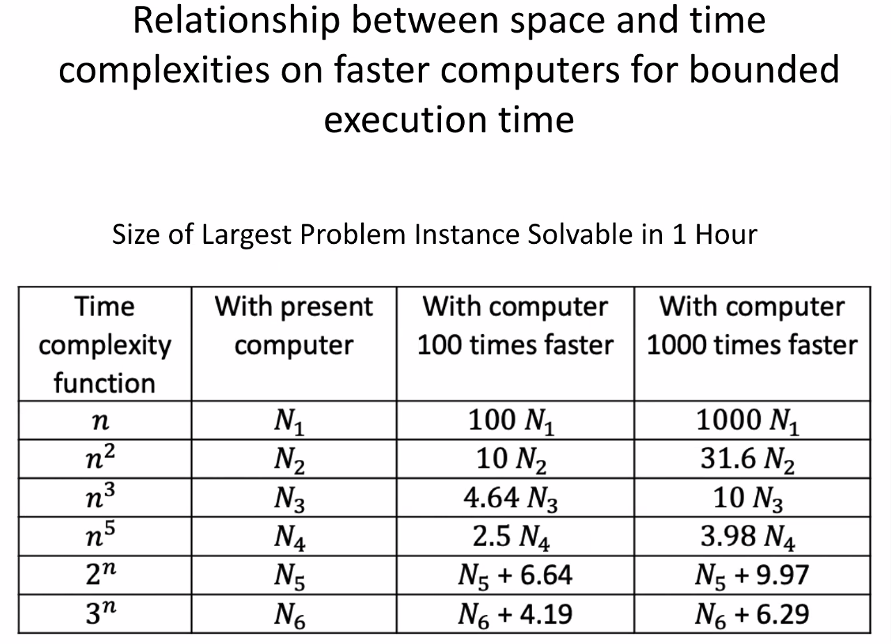
       1. Faster computer =/= better time complexity
   14. 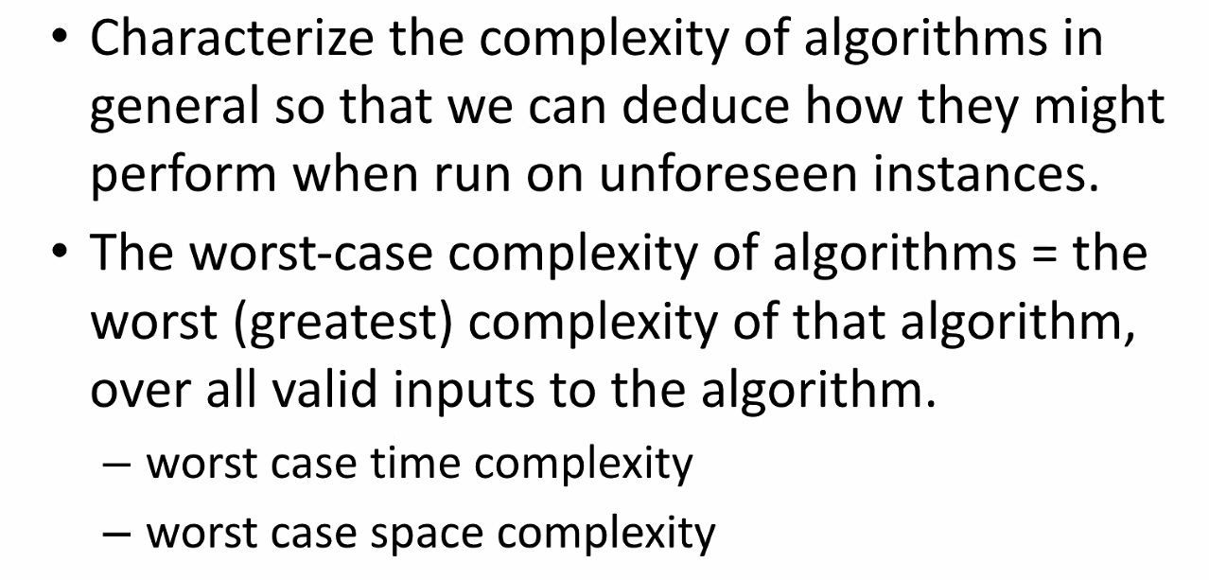
   15. 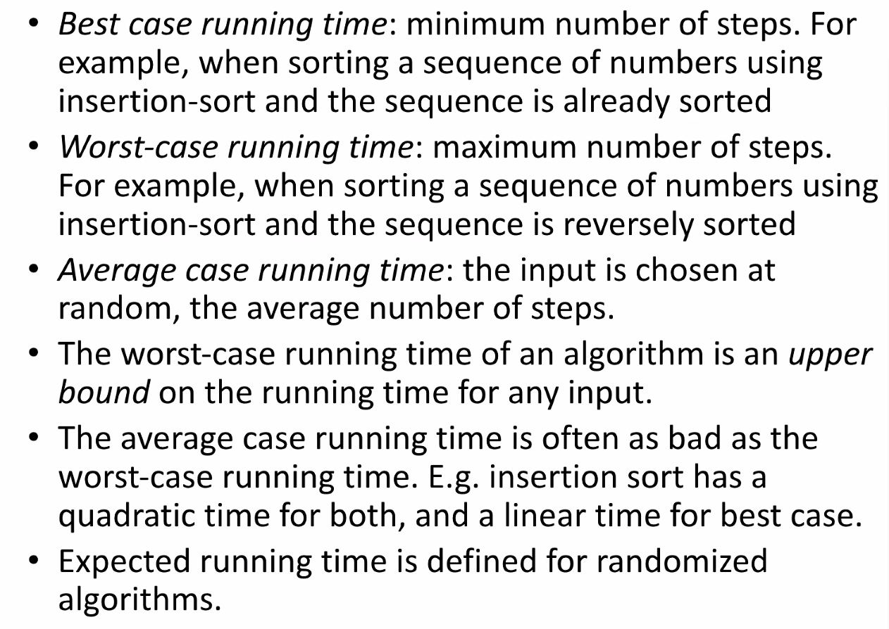
   16. 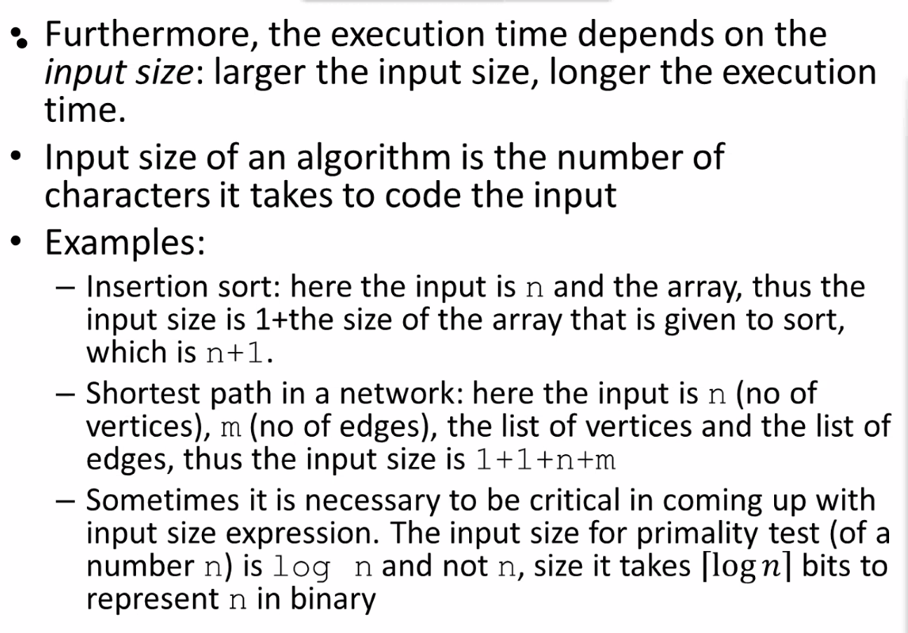
   17. 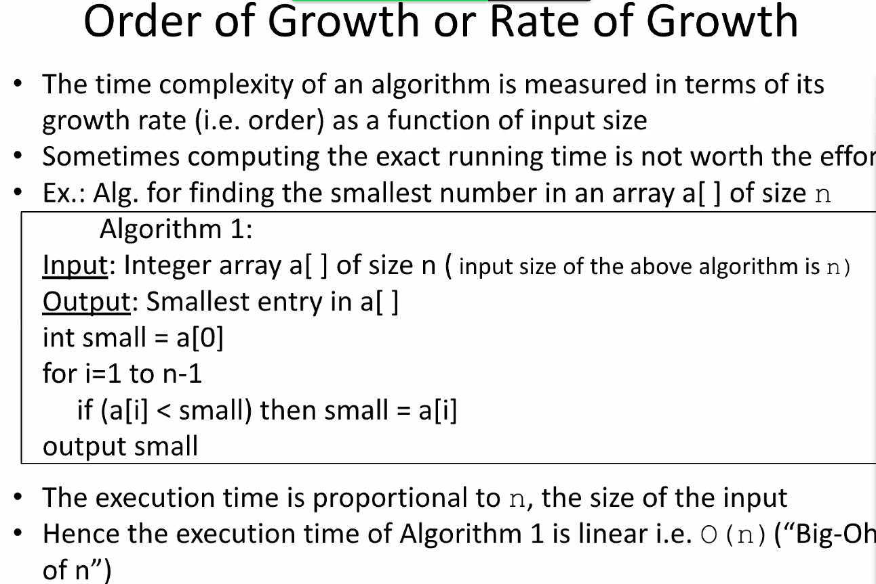
   18. 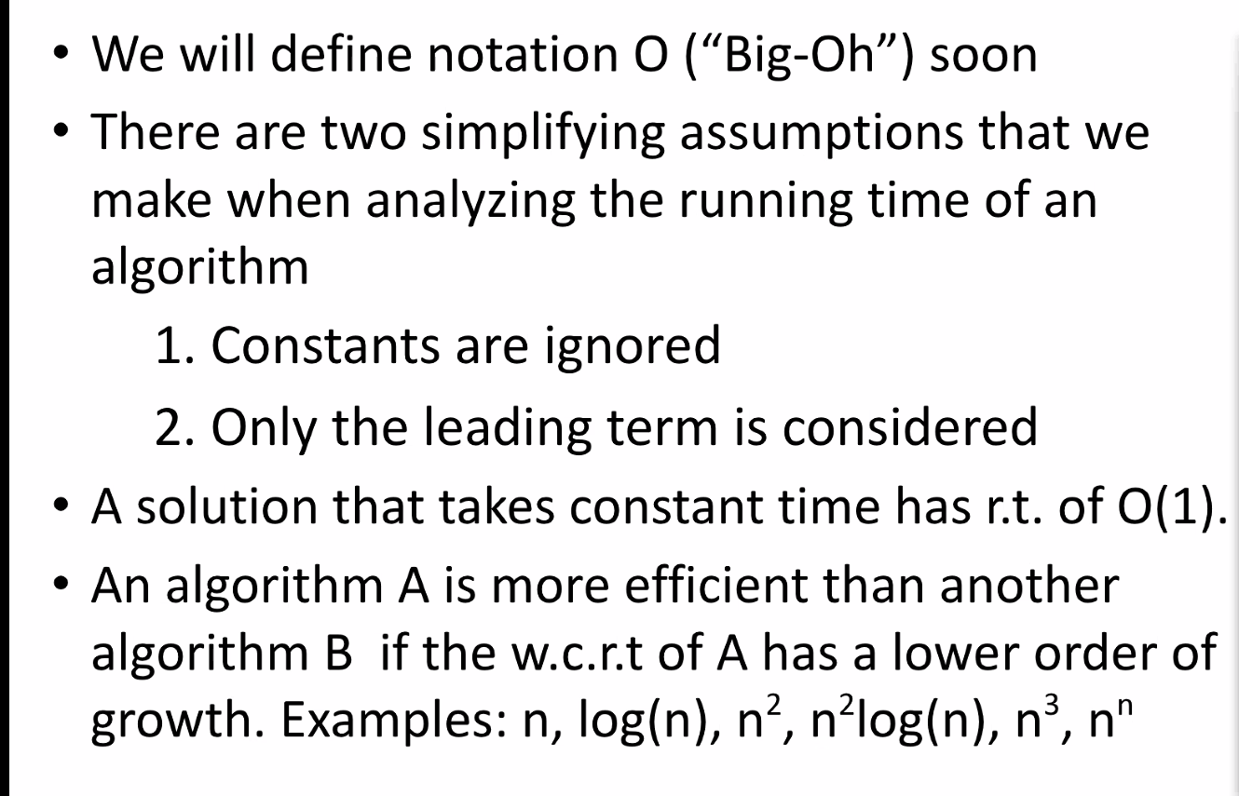
   19. 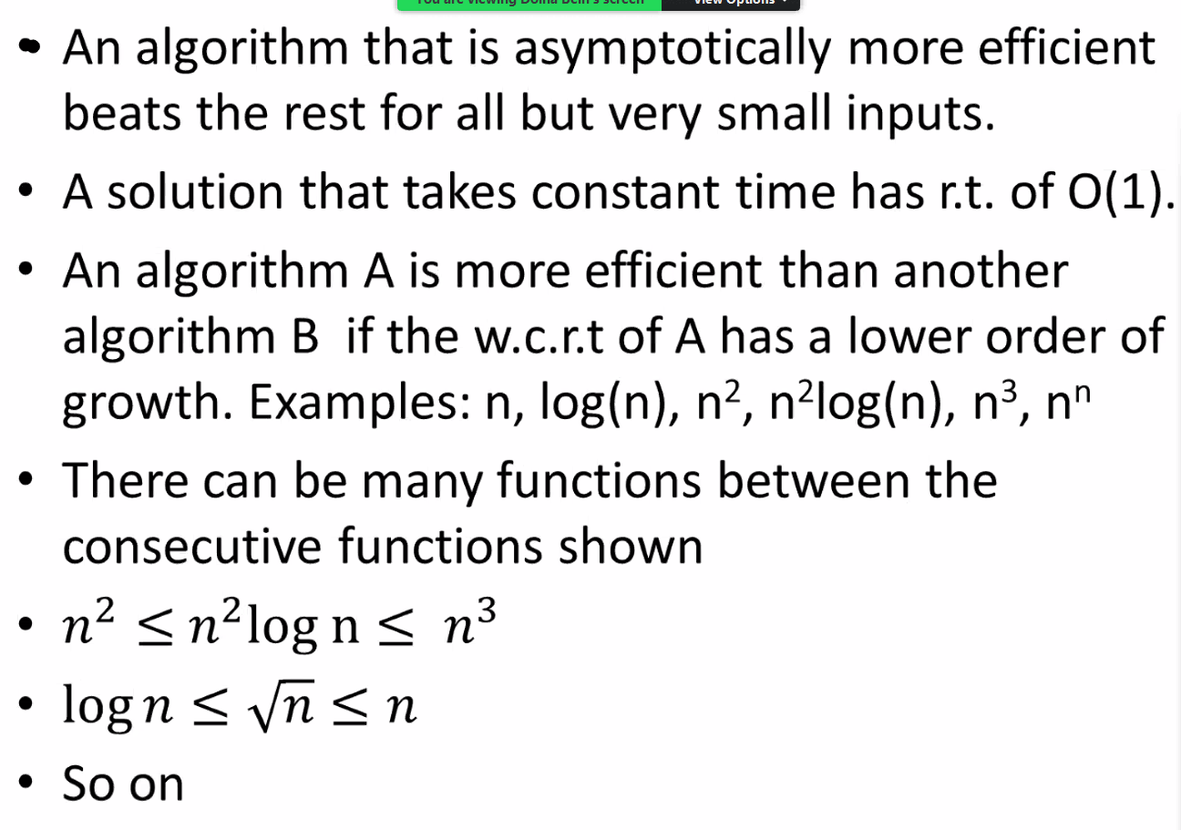
   20. 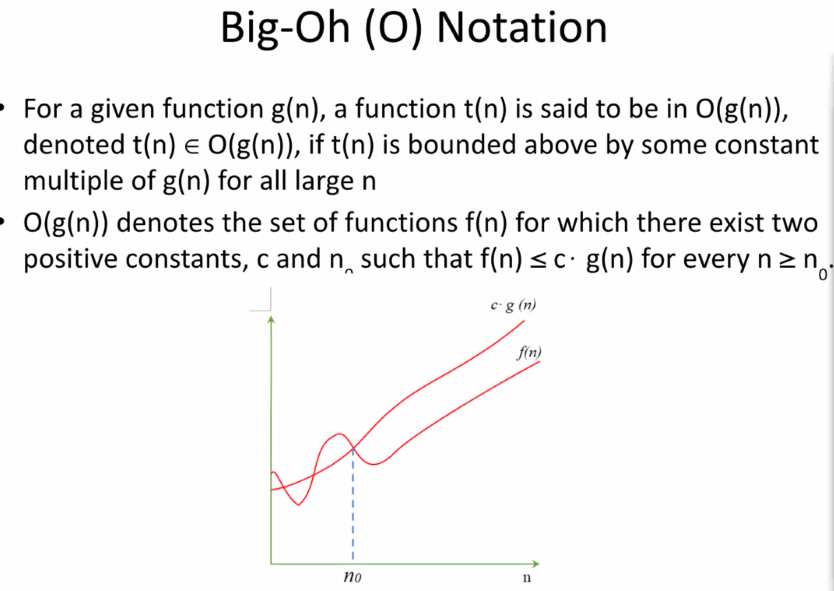
   21. 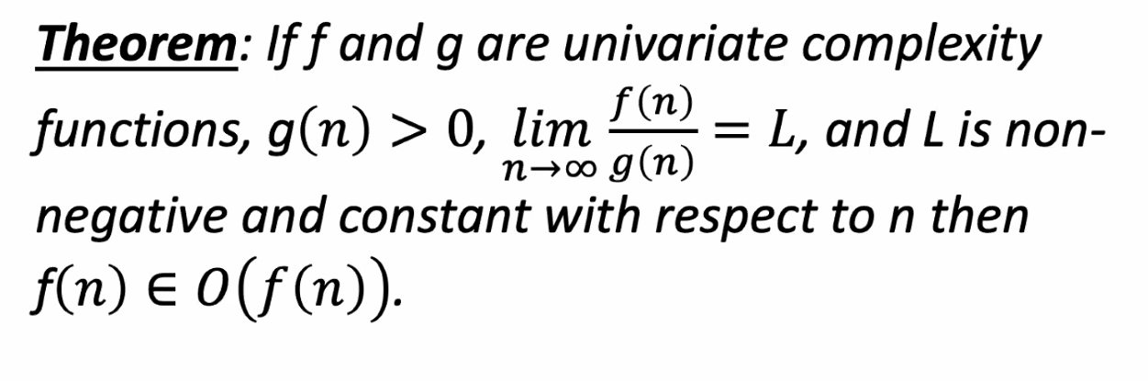
       1. This is in response to the 5 problems we were presented (or rather skimmed through).
       2. Definition + Limits theorem = the best ways to determine Big-O complexity
   22. 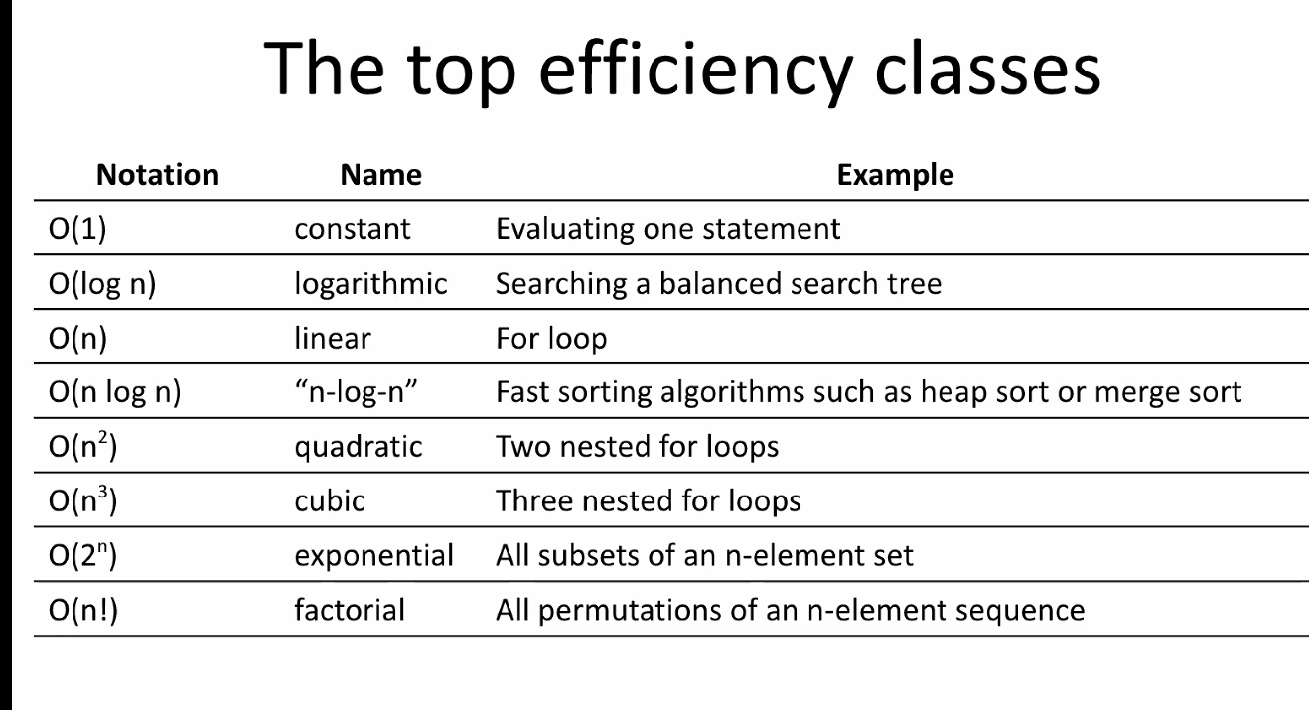
   23. 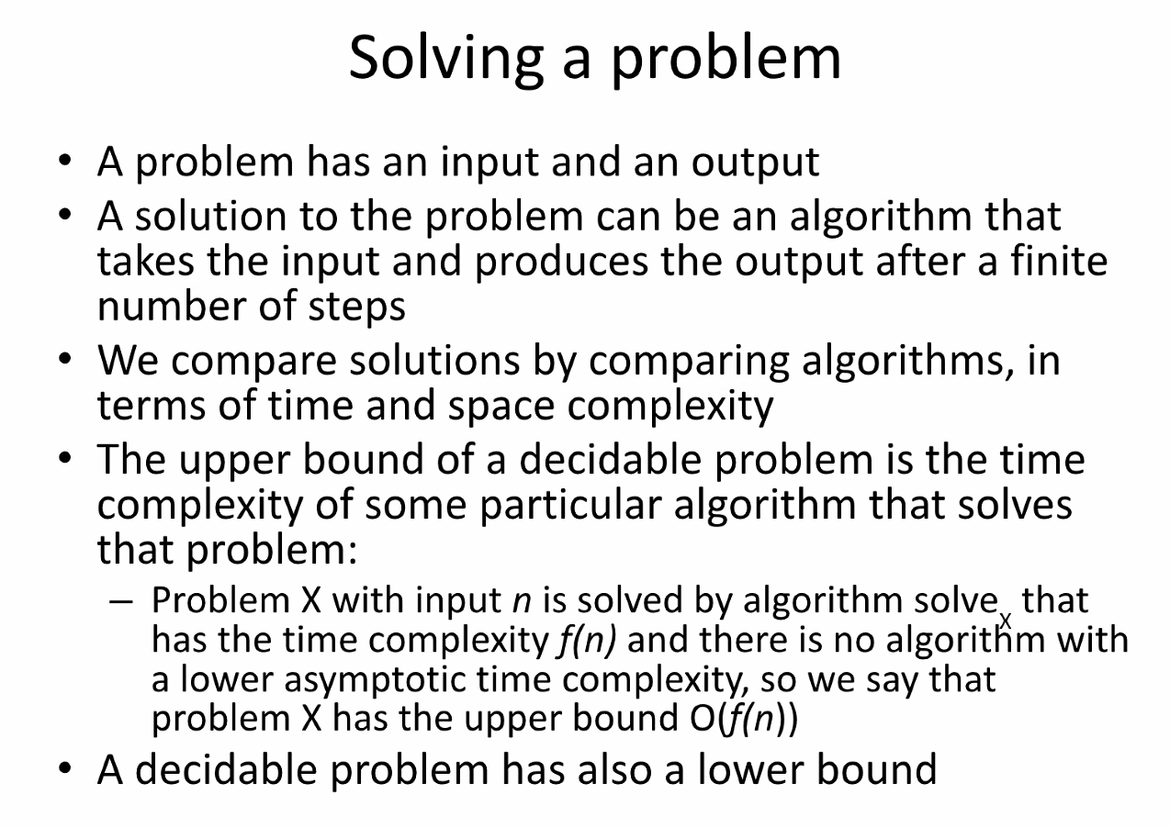
   24. 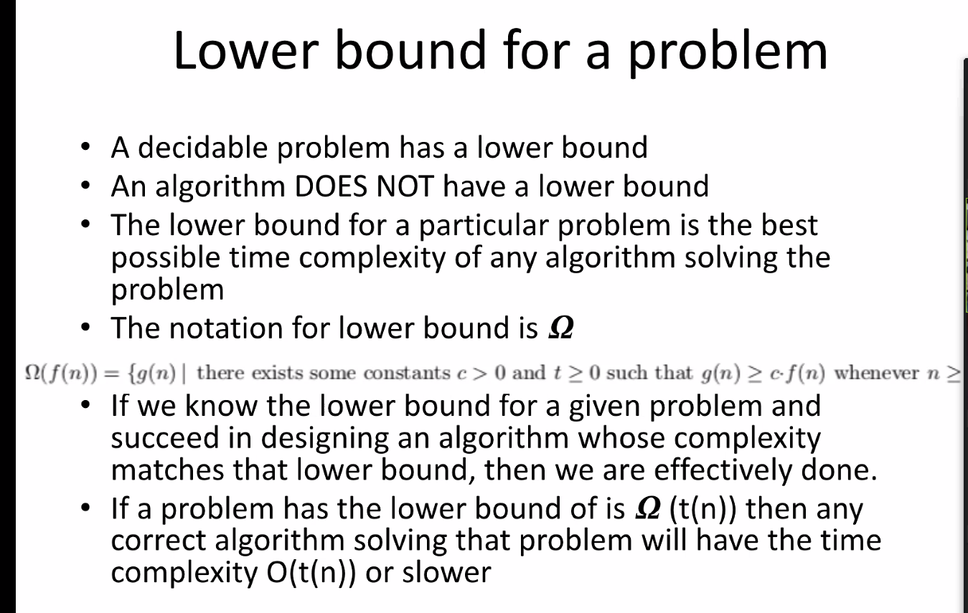
   25. 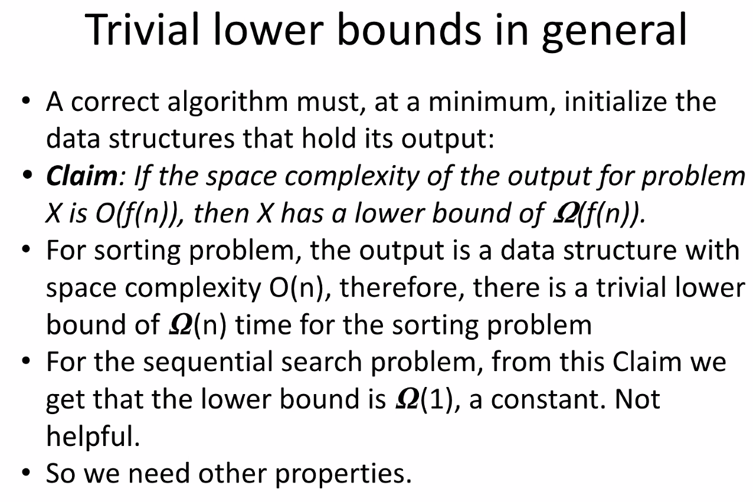
   26. 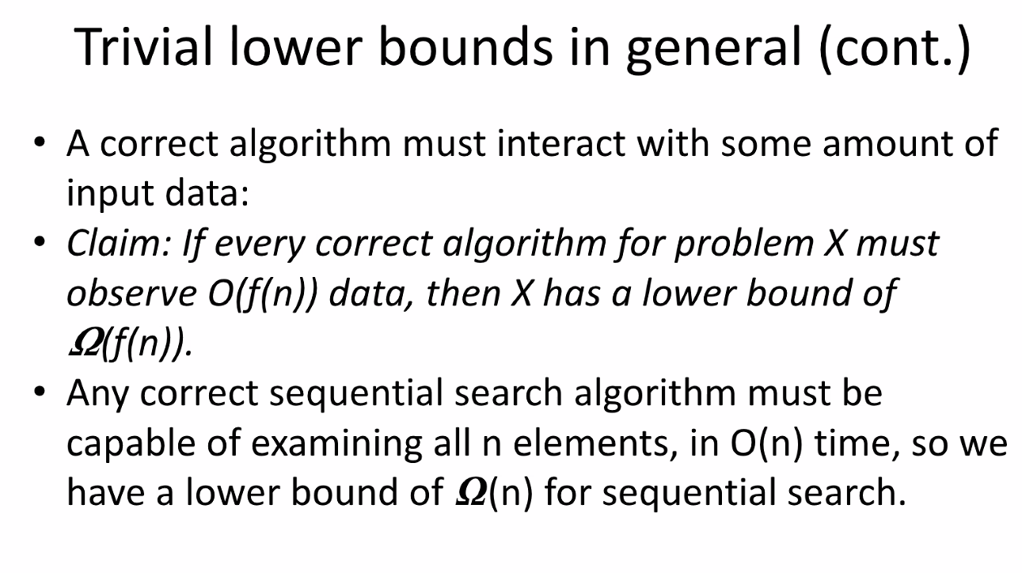
   27. 